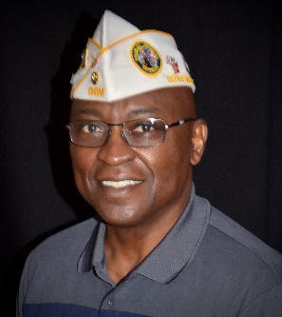

Francis Mitchell
Department Commander

Francis Mitchell, a service-connected disabled veteran of the U.S. Air Force, became the Department Commander on 18 June 2022.

Mitchell joined the Air Force in 1969 and served for 31 years in various roles in the aviation career field. He served tours in Vietnam, Alaska, Florida, Greenland, Maryland and others, completing his career at the Pentagon as the Air Force Career Field Manager for over 11,000 Career Enlisted Aviators (CEA) and 3,000 other enlisted aircrew members. Francis retired in 2000 with the rank of Chief Master Sergeant

After retirement, Mitchell has worked at Joint Base Langley-Eustis Virginia since July 2000 as an Acquisition Program Manager in the Directorate of Requirements where is responsible for the $3.5 Billion dollar Joint Surveillance Target Attack Radar System (Joint STARS), 16 aircraft program at Robins AFB, Georgia. Francis also earned has two Associates Degrees and a Bachelor of Science from Embry-Riddle Aeronautical University in Professional Aeronautics.

A life member of Chapter 6, Francis has served as the Local Volunteer Assistance Program (LVAP) Coordinator and served in various other leadership positions including Chapter Commander. He lives in Suffolk, VA with his wife Mona.
Francis previously served as the Department Assistant Inspector, and the Department Senior Vice Commander.

